Shop Nest Store Dashboard Report

Table of Contents
1. Introduction
2. Objective of the Dashboard
3. Key Metrics and Insights
4. Analytical Questions and Visualizations
4.1 Top Categories by Total Price
4.2 Delayed Orders Analysis
4.3 Monthly Comparison of Delayed and On-Time Orders
4.4 Payment Method Analysis
4.5 Product Rating Analysis
4.6 State-wise Sales Analysis
4.7 Seasonal Sales Patterns
4.8 Revenue Analysis
5. Conclusion and Recommendations

1. Introduction
These anonymized datasets mimic real-world e-commerce data and include customer transactions, product information, and delivery details. The goal of this project is to showcase data modeling, visualization, and business insight extraction through Power BI.

2. Objective of the Dashboard
The primary objective of this dashboard is to analyse customer behaviour, product performance, and sales trends while identifying delivery performance and customer satisfaction levels. It aims to assist stakeholders in making informed decisions based on real-time data insights.

Visualization –
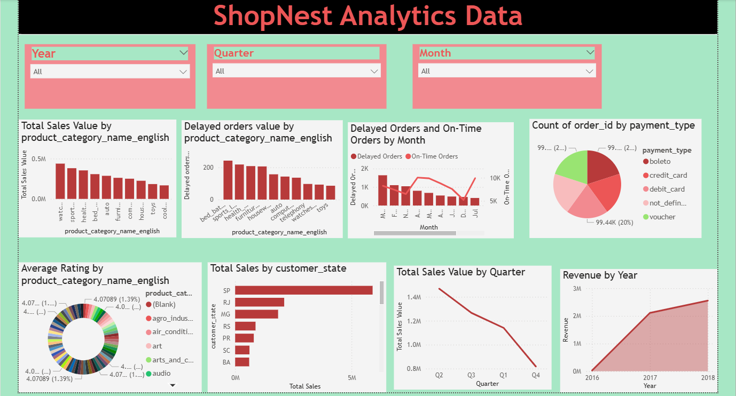

3. Key Metrics and Insights
The dashboard highlights the following key metrics:
- Total Sales
- Total Orders
- Average Review Score
- Total Revenue State wise

4. Analytical Questions and Visualizations

4.1 Top Categories by Total Price
Question Statement: Identify and visually represent the top 10 product categories by total sales.
Visualization –

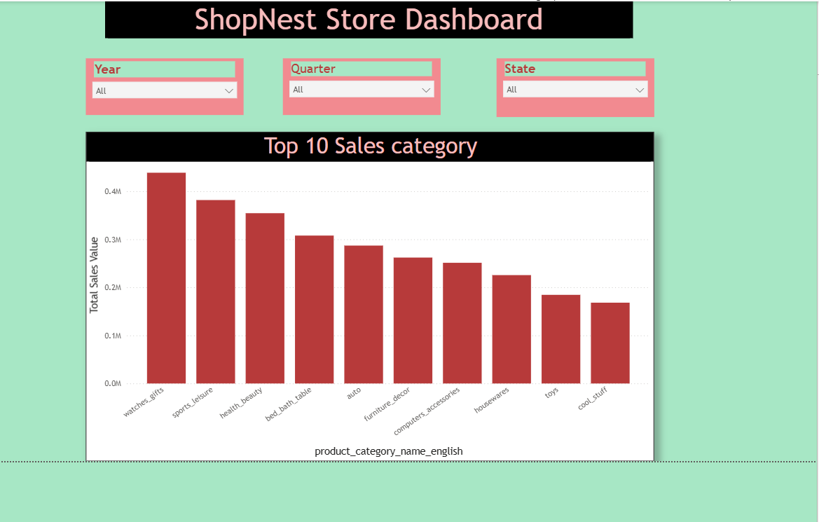Explanation: This analysis highlights the top-performing product categories by total sales. It helps identify which categories drive revenue and align marketing efforts accordingly.

4.2 Delayed Orders Analysis
Question Statement: Determine the number of delayed orders in each category.
Visualization –

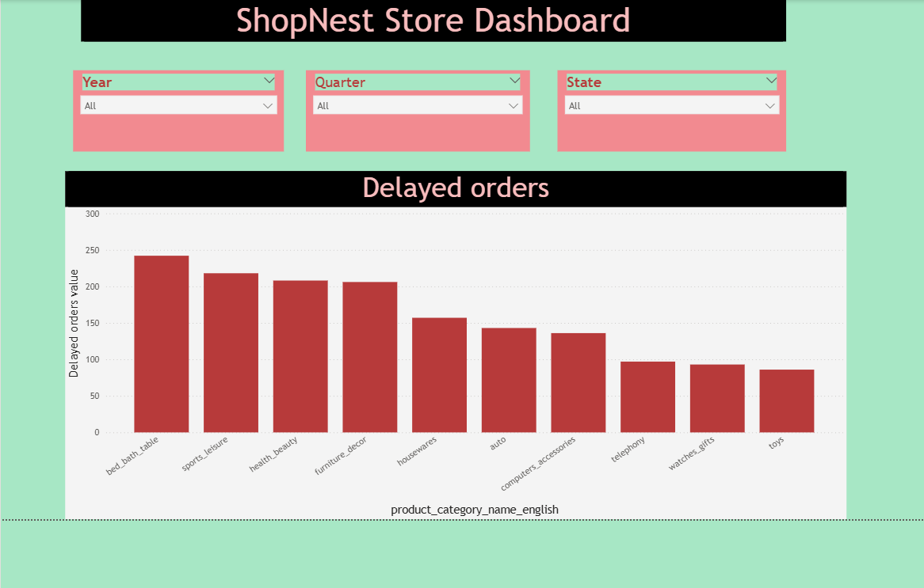

Explanation: This analysis identifies the product categories with the highest number of delayed deliveries, enabling targeted interventions to improve delivery performance.

4.3 Monthly Comparison of Delayed and On-Time Orders
Question Statement: Compare the number of delayed orders to on-time orders for each month.
Visualization:
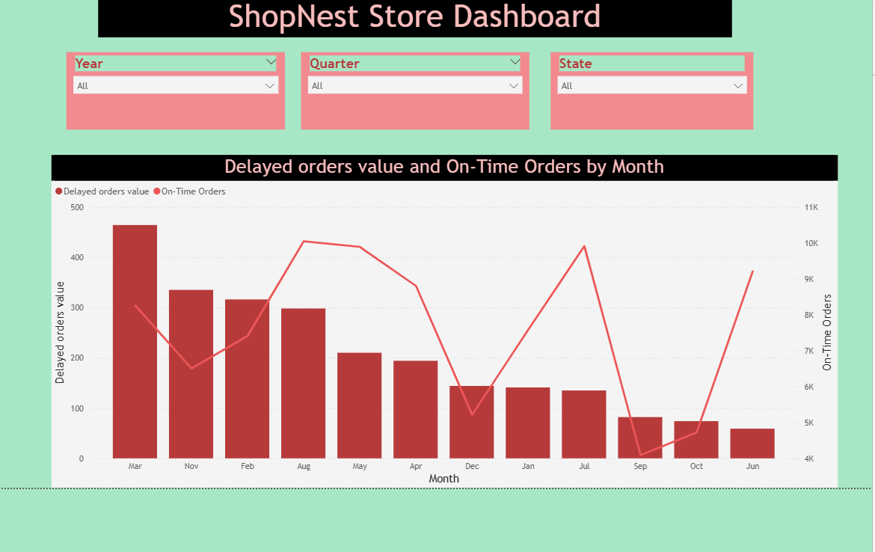
Explanation: This visualization tracks delivery performance over time, highlighting trends in on-time and delayed orders and helping address seasonal challenges.

4.4 Payment Method Analysis
Question Statement: Analyse the most frequently used payment methods by customers.
Visualization:

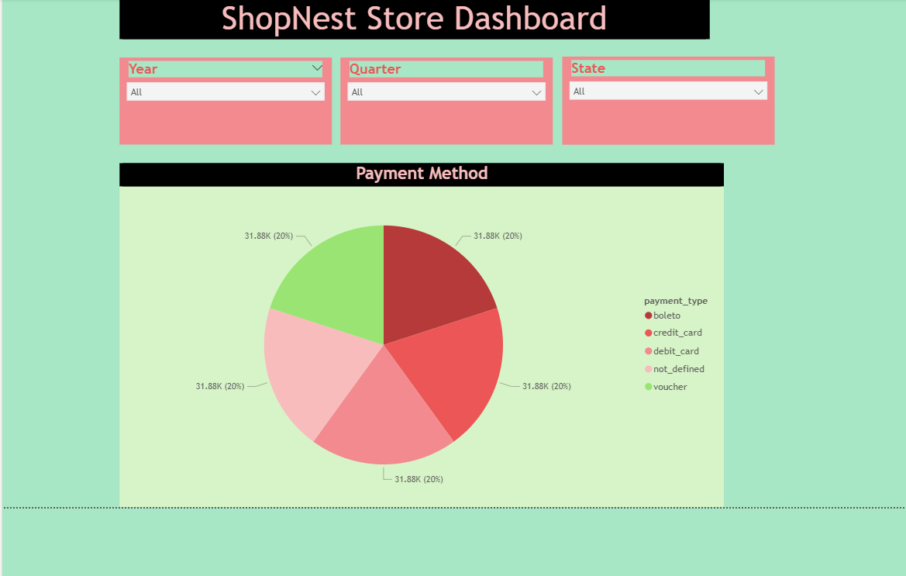
Explanation: Understanding the most popular payment methods allows the business to enhance customer payment experiences and identify preferred modes.

4.5 Product Rating Analysis
Question Statement: Determine the top 10 highest-rated products and bottom 10 lowest-rated products.
Visualization:

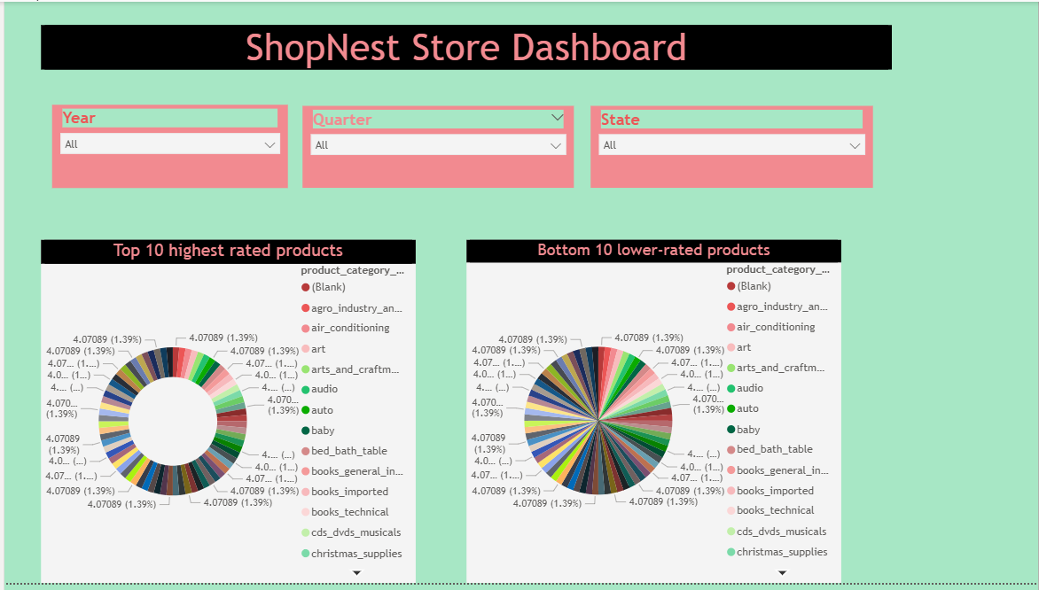

Explanation: This analysis helps identify well-performing products and address issues with poorly rated products to enhance customer satisfaction.

4.6 State-wise Sales Analysis
Question Statement: Identify states with high and low sales.
Visualization:

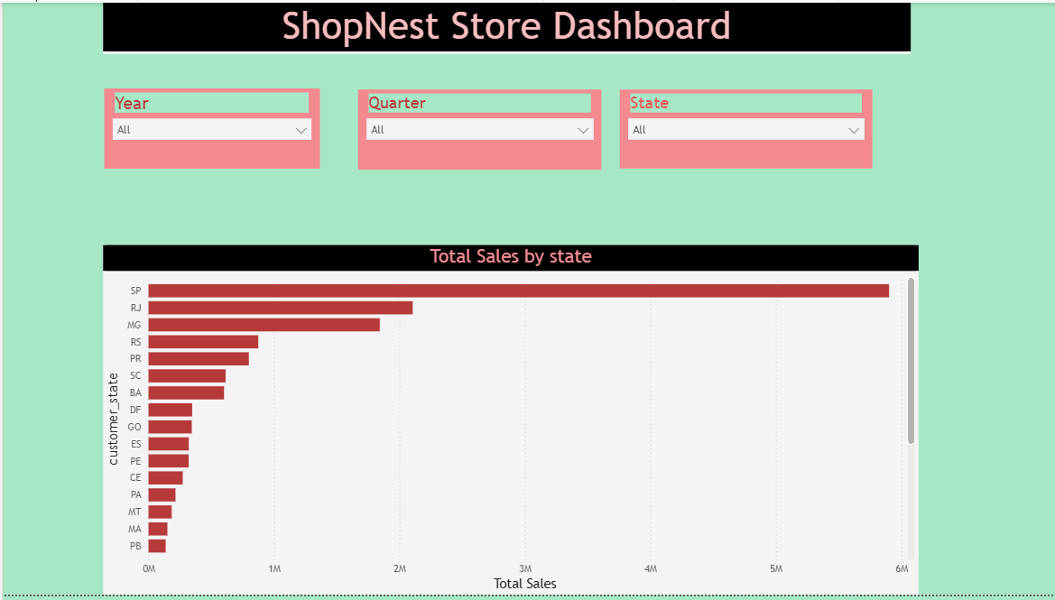

Explanation: This visualization provides a regional overview of sales performance, allowing for targeted marketing and resource allocation.

4.7 Seasonal Sales Patterns
Question Statement: Investigate seasonal patterns in sales data.
Visualization:

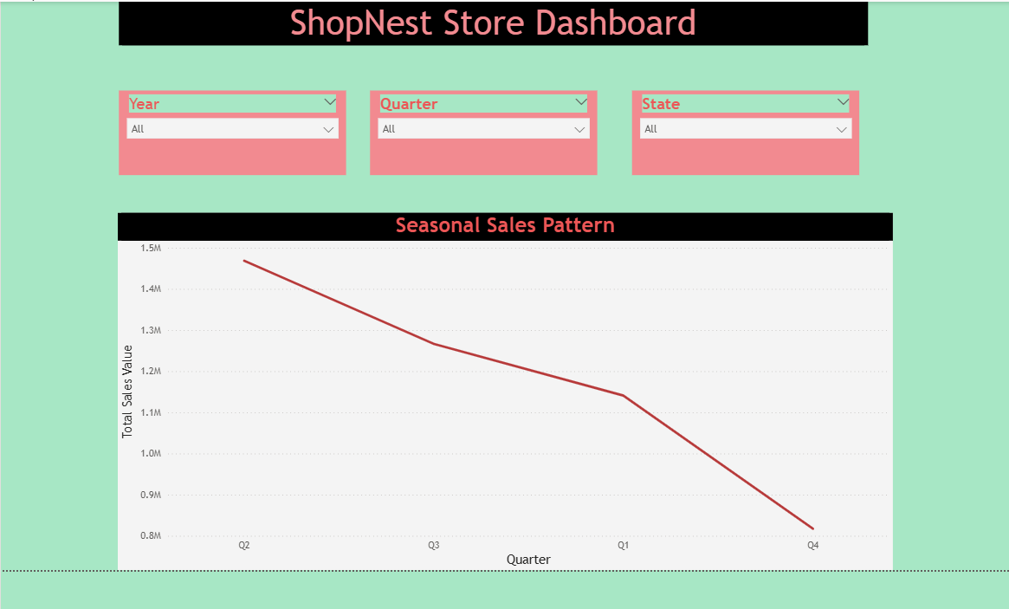

Explanation: This analysis identifies quarterly trends in sales, helping businesses prepare for peak seasons.

4.8 Revenue Analysis
Question Statement: Analyze total revenue and its changes over time.
Visualization:

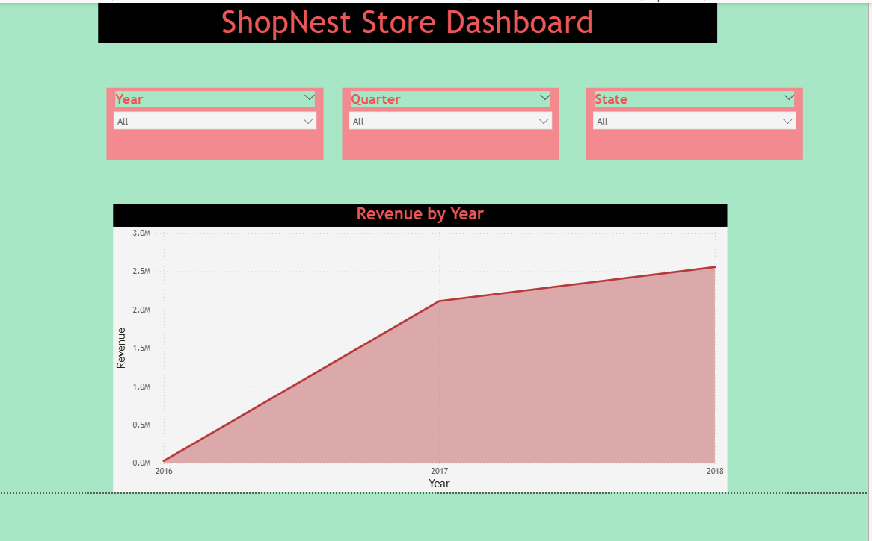
Explanation: This visualization tracks revenue trends over the years, highlighting significant growth or decline patterns.

5. Conclusion and Recommendations
The ShopNest Nest Dashboard provides valuable insights into various aspects of the e-commerce business. Based on the analysis, the following recommendations are made:
- Focus marketing efforts on top-performing product categories.
- Improve delivery processes for categories with the highest delays.
- Optimize payment methods to cater to customer preferences.
- Address issues with poorly rated products to enhance customer satisfaction.
- Leverage regional and seasonal trends to maximize sales opportunities.

